# CS 255 System Design Document Template

## UML Diagrams

### UML Use Case Diagram

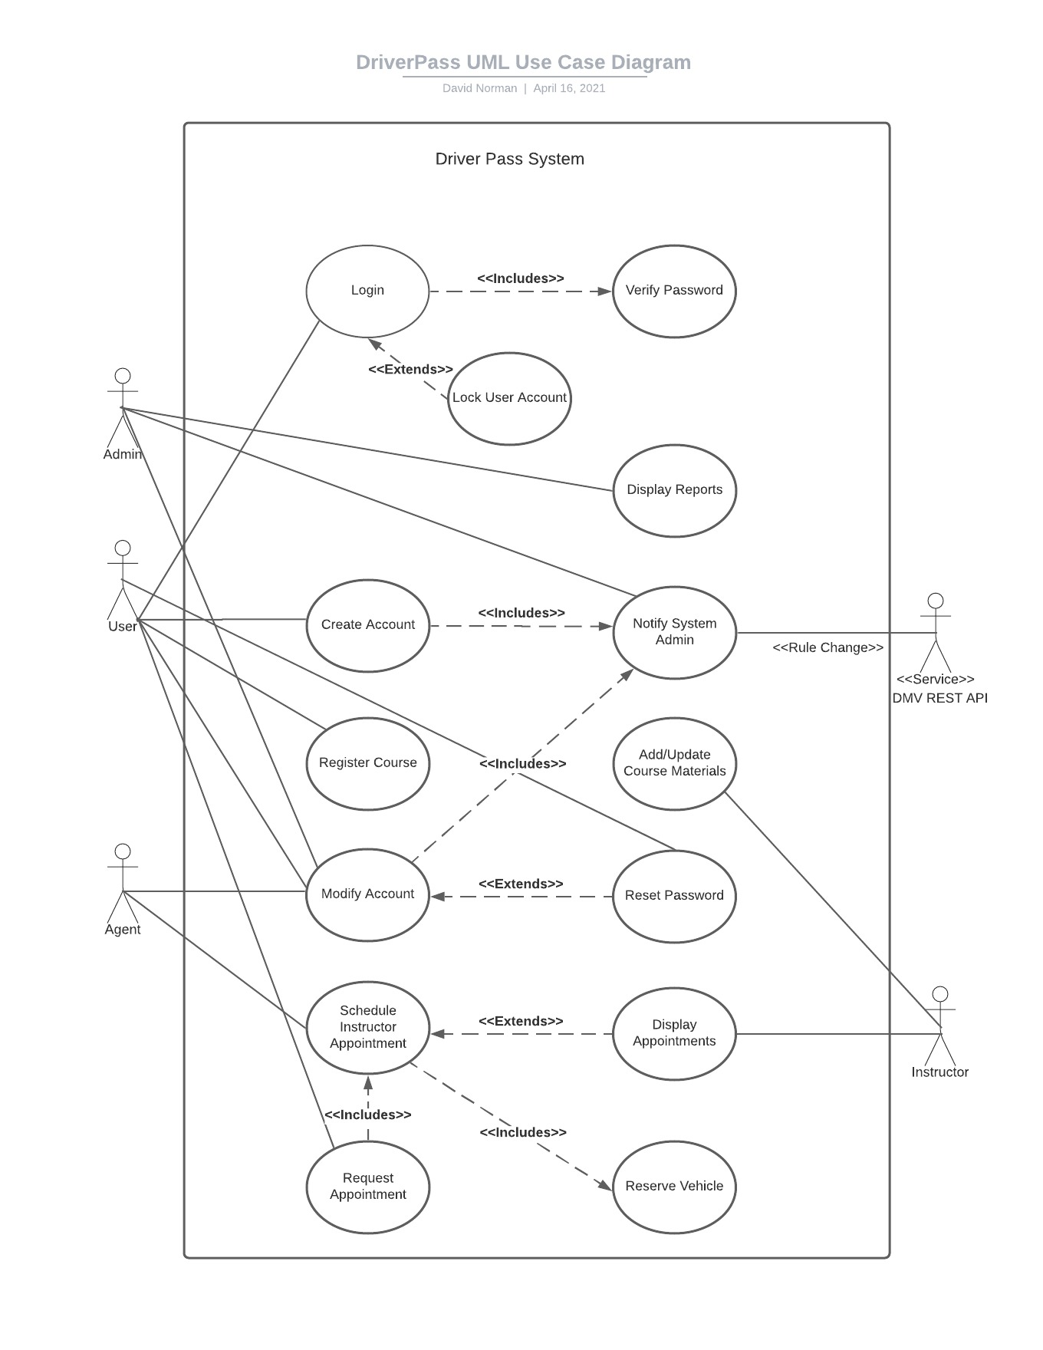

### UML Activity Diagrams

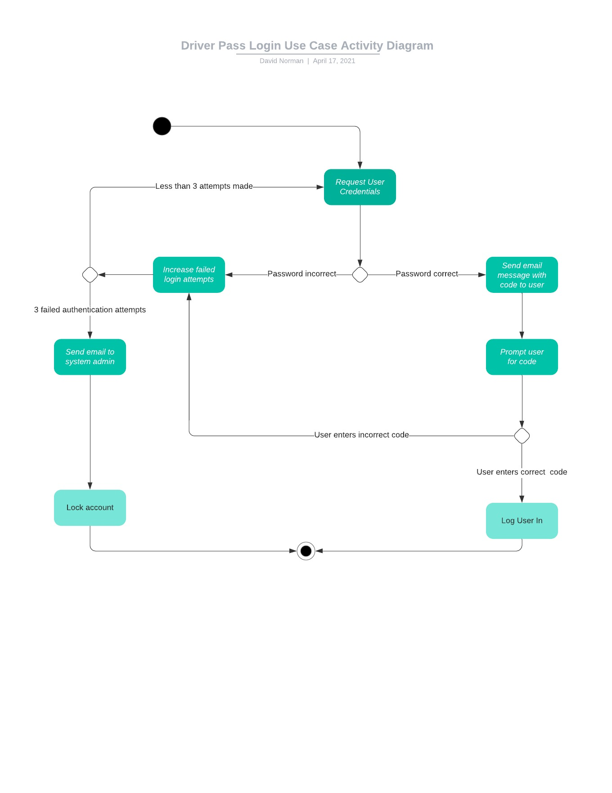

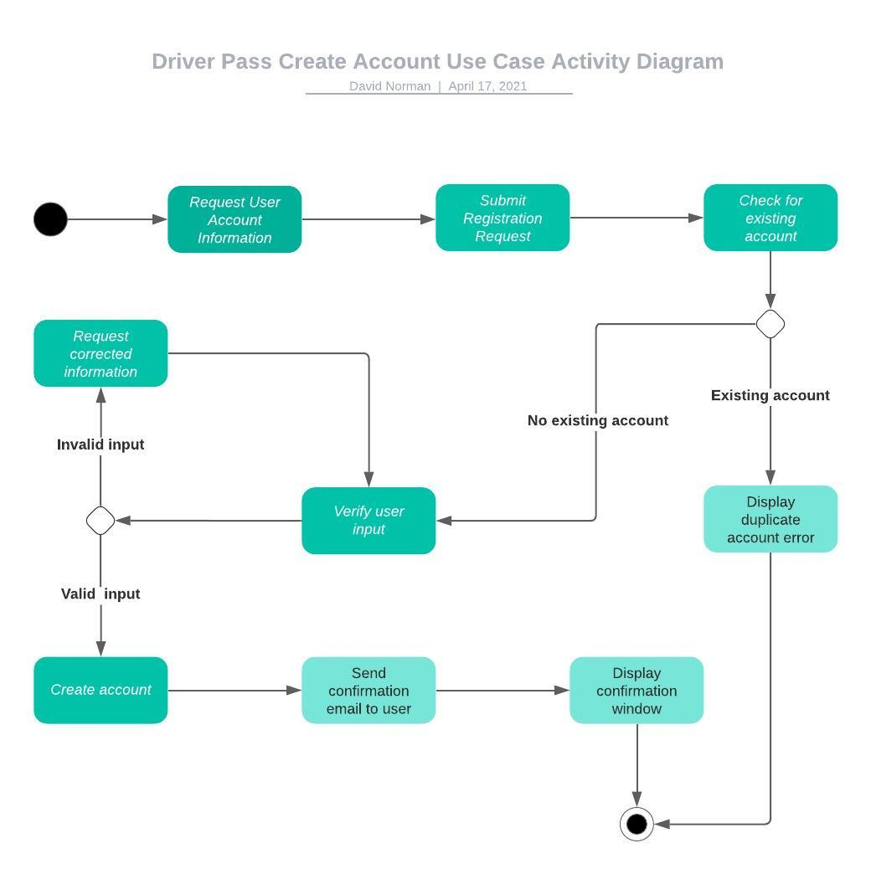

### UML Sequence Diagram

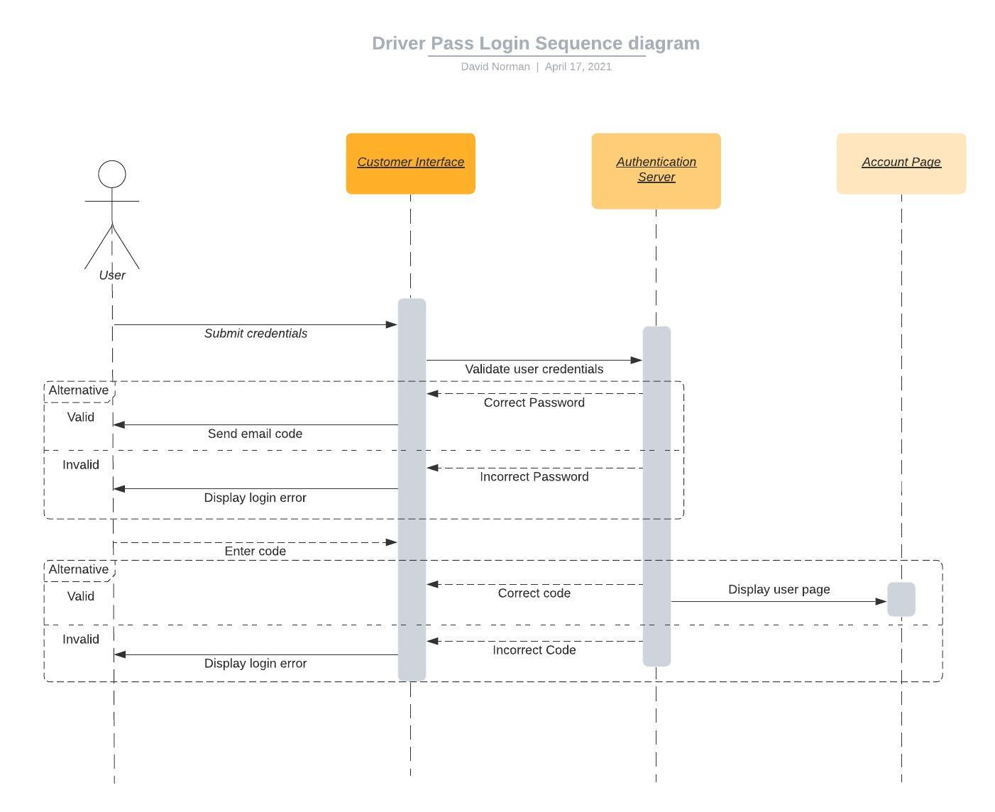

### UML Class Diagram

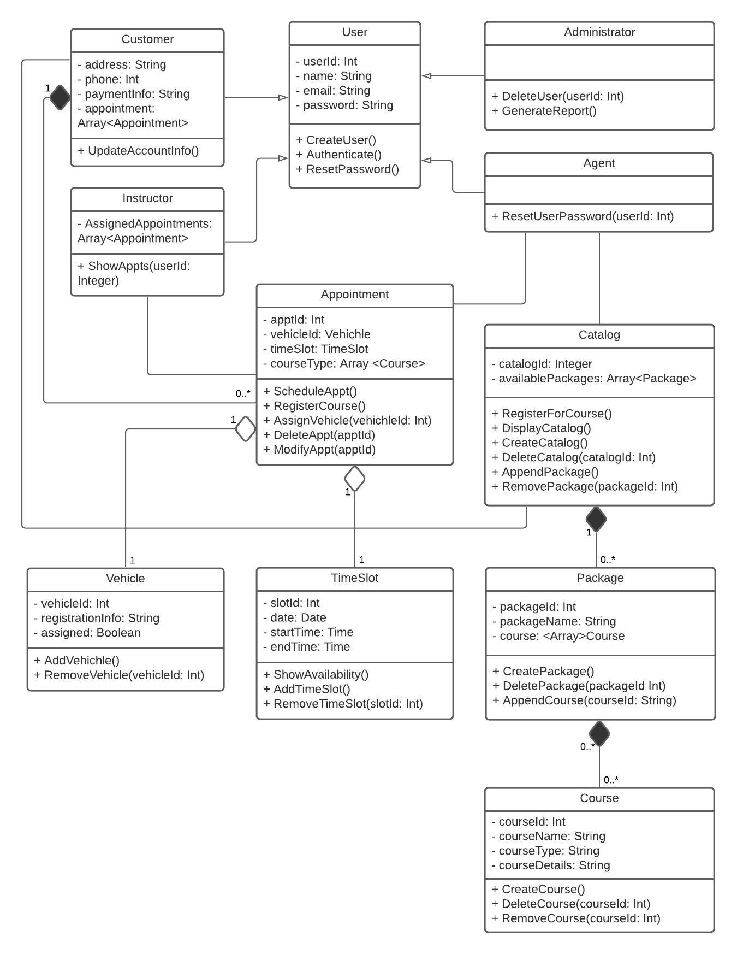

## Technical Requirements

The DriverPass company has decided to venture into the untapped market of online driver education. The company wants to be the first to provide its users with online DMV training materials, practice tests, and the ability to schedule a behind-the-wheel session led by an instructor and provide a student vehicle.

They wish to build a system that will be able to deliver content and provide access anywhere over an Internet connection. Their customers should be able to operate the system over any mobile device or PC operating system platform. The system will provide their customers with a personal account and history of activities, integrate with the DMV systems to keep current with rules and regulations, and provide the capability for users to schedule appointments using the company’s various assets, such as personnel and vehicles.

As stated in the business requirements documents we provided, much functionality has been suggested for the design of this project. The following section contains the complete technical requirements as we see them relating to the final design diagrams (shown above).

While the primary goal is to achieve as much of the system design in the cloud as possible, there will still be an opportunity to retain some on-site hardware and infrastructure to support the program.

Recommendation for Infrastructure

* Cloud service license with Amazon (AWS) with support for web-hosted services (starting with a single server, but can grow as needed)
  + Hosted Database Services Subscription (within AWS)
* Bandwidth subscription to support anticipated load on the hosted services and for local connectivity to the Cloud
* Two local servers to support local reporting and backup data collection while not connected to the primary systems on the cloud
* A local area network set up for office operations and system administration

Recommendation for Software

* Microsoft Exchange licenses (to support reservation scheduling, emailing, and calendaring)
* MS Office 365 Licenses for all office workstations supporting client email and reporting
* All versions of current web browsers to provide user support
* Cloud-based Learning Management System (LMS) subscription

Recommendation for Hardware/Tools

* Online payment processing services
* Local computers (for each employee in the office)
* Android and iOS smartphones (for any support staff who will be assisting customers)